Multiagent Organizations

Original Chapter by Virginia Dignum and Julian Padget, edited by G. Weiss - „Multiagent Systems”

Paper written by DLarisa – January 2022

Contents

1.Introduction: 2

2.Multiagent Organizations: 4

3.Institutions: 9

4.Agents in Organizations: 15

5.Evolution of Organizations: 17

6.Conclusions: 18

7.References 19

# 1.Introduction:

In order to better understand the notions presented in this paper, one should think of real-life situations and the *modus operandi* of humans in different scenarios that involve large clustering of individuals, such as organizations or hierarchies, as multiple theoretical constructs from this field find their origins in sociology.

Before we define what a ***multiagent organization*** is, let’s start with the basics and first understand what an agent is. **An agent** is a single entity, that exists in a particular environment and is capable of executing certain independent actions that have a direct consequence of the given environment, with the purpose of achieving its designated goals [1]. The classic example of such an agent is a thermostat that is able to read the room temperature and turn on and off the heating. But we can hardly call the thermostat or the old alarm clock **an *intelligent* agent**. So what are the prerequisites that transform an agent to an intelligent one? As presented in [2], there are three:

* **Reactivity**: the capability of reacting to a dynamic environment;
* **Proactiveness**: taking the initiative in order to achieve their goals;
* **Social Ability**: the capability of interacting with other agents (or, possibly, with other humans) in order to complete their objectives.

An example of an intelligent agent could be the computer that plays chess. But do agents need a form of management or it is sufficient for them to act alone? Just like in human institutions, teamwork can be more efficient because it ensures that every entity can focus on what it knows to do best and cooperate with others (via different methods such as negotiation) so that together can reach their target, so the answer is *YES*.

A group of intelligent agents that work together to solve tasks that exceed their individual capabilities is defined as **a multiagent system** (MAS) [3]. But MAS has its own limitations, as presented in [4]:

* Each agent has insufficient knowledge or ability to reach the system’s target;
* There isn’t a global control over the agents;
* The obtained data is not centralised;
* The computation is asynchronous.

One problem with MAS is the social aspect of agents because they can either collaborate or they can be selfish and require coordination techniques such as sharing or auctions. Because of this, MAS is predesigned with a specific agent-type in mind, but this approach brings a huge disadvantage in terms of outside agents being almost incapable of joining the system and the inside ones being „hard-coded” to pursue global requirements of the MAS (instead of each one having their own unique goal and together fulfilling the objective of the system); all of these factors resulting in a system that is difficult to maintain and develop. So, a new approach must be adopted because:

* Interaction of agents cannot be based only on communication;
* MAS engineering requires high-level abstractions, in order to account for a global target that is not automatically assumed by the agents;
* There is a need for explicit social roles in the system inhabited by the agents.

The solution is to refactor the system so that the focus is *organization-centric*: building an explicit depiction of the **organization**, which is independent from the agents architecture. The organization becomes an entity in itself. According to systems theory, an organization is more than the sum of its components and organizational behavior is defined by the interrelationships of its parts [5]. Considering this, it is obvious that an organization can impact the environment in which resides and its agents and vice versa. A good example from [1] is to think of a university: the university’s goal is to be a place of learning and producing research, but it cannot exists without the agents (students and professors) that have their own ambitions (e.g. getting a degree). So we have an interdependent relationship.

Depending of the point of view of the discusion, organizations can be viewed either as an entity (sociology and organization theory), with its own needs and goals, or can be perceived as the set of all its agents (distributed AI). Throughout this paper, we will refer to the organization as an individual in itself.

To summarize, from an agent perspective, organizations ensure that they have a better integration in the system, by delegating tasks or helping them adapt to changes in environment. From MAS point-of-view, organizations establish global behaviour and coordination, in order for the common goal to be achieved.

We can notice, thou, a conflict of interest between organization and the agents: Similar to the MAS situation where we don’t know if the agents are going to coordinate, organizations cannot expect compliance from them in solving the global problem, as their interests might diverge. The issue arises from the fragile balance of ***regulation*** and ***autonomy***, 2 concepts that define multiagent organizations [6]. ***Regulation*** refers to directed behaviour, leading to lack of flexibility; a strict set of rules are very likely to not consider individual capabilities and result in work not being done efficiently. On the other hand, ***autonomous*** behaviour refers to the ability of making your own decisions but it’s insufficient in social situations, where we encounter coordinating processes. As such, the organization must describe a framework that combines these two notions, reaching a balance that satisfies the global scope (it is a design decision in the end) and so, the following requirements must be met [7]:

* **Internal Autonomy**: the organization’s architecture must be designed separately from the internal structure of the agents;
* **Collaboration Autonomy**: construct the organization without fixing all possible protocols in place.

In the following chapters we are going into details regarding multiagent organizations and throughout the paper we are going to use the following example from [1], that will help us map the theory into practice, for a better understanding of the subject:

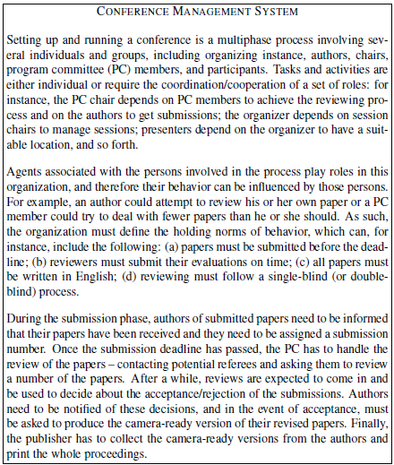

Figură 1 - Conference management system

# 2.Multiagent Organizations:

Multiagent organizations can be divided into 2 categories: *structural* or *institutional*. The main difference between them is that an institution is a structure that reinforces social interaction by establishing and enforcing norms/rules [8].

As stated previously, a multiagent organization is derived from MAS using sociology concepts, the most important one being the notion of ***role***, not to be confused with *actor/agent*. We mentioned above that the purpose of an organization is to describe a common objective and delegate particular entities for specific tasks, thus ensuring the fulfilment of the global target. So it makes sense to commission an appropriate agent for a suitable assignment, creating roles. Separation of concerns is therefore conceivable in accordance with the regulation-autonomy balance presented above.

As we know from real-life, some companies prioritize efficiency over quality of products, others have the exact opposite business strategy, so it is important for them to know how to allocate resources and people to achieve their mission. This is also linked with the environment in which they operate and with the demands coming from it, so an organization must take into account all these factors in order to delegate a proper ***coordination mechanism*** 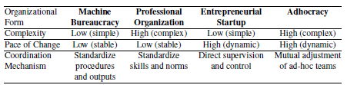for the **roles** inside it. According to Mintzberg, we have the following organizational forms [9]:

Figură 2 - Organizational forms according to Mintzberg

Inspired by his work, researchers have proposed different classification systems, including, but not limited to [10]: bureaucracy, matrix, team, virtual, simple, alliance etc..., but, often times, the process is quite unclear and results in hybrid classification.

Organizations are comprised of components, that can be catalogued into 3 major classes:

* ***Environmental aspects***: everything that is linked or dependent on the environment such as available resources, time constraints or size of different activities enterprised in it...;
* ***Structural components***: the elements of organization itself, viewed as a structure (e.g. norms, rules, methods, roles...);
* ***Agent factors***: the sum of all the characteristics that define the agents that inhabit the organizations (e.g. social awareness or task capability).

To break it down and get an even deeper understanding of the organization’s „*anatomy*”, its major components are:

* ***Entities*** (e.g. *roles, sub-groups, positions, agents*...): they represent the population of the organization, the elements that, at a higher level, could be characterized as dynamic, because they „do”/„act” something/in some way. They are independent, expected to be intelligent/rational and gifted with some type of skills;
* ***Relationships*** (e.g. *coordination, negotiation, cooperation*...): the organization is expected to establish order among its entities and draw the relationships between them, to the purpose of accomplishing a greater goal that exceeds one individual skill alone, as it is the responsibility of the multiagent organization to achieve the global objective. Some possible relations: delegation of tasks, access to different resources, synchronization of actions, transfer of useful informations...;
* ***Goals*** (intentions, targets): as mentioned above, the organizational goal is not implicitly the ambition of its agents, so a global strategy is required, using local decisions;
* ***Norms*** (rules, patterns): are imposed by the organization and can be divided into 2 (the organization must balance control and efficiency – design choice):
  + *Constraints*:not flexible, cannot be disobeyed;
  + *Regulations*: flexible, the agent can decide what course of action should follow.
* ***Environment***: it’s the space the organization inhabits. The relationship between organization and environment is bidirectional, as the environment influences the decisions made by the system and those choices affect the environment. Most environments are:
  + *Dynamic*: meaning that agents can evolve, their behaviours and actions can change, the environment responds to the organization’s activity or has external influences etc...
  + *Open*: the information is shared between entities, distributed management, organization’s components are not supervised by only one entity etc...

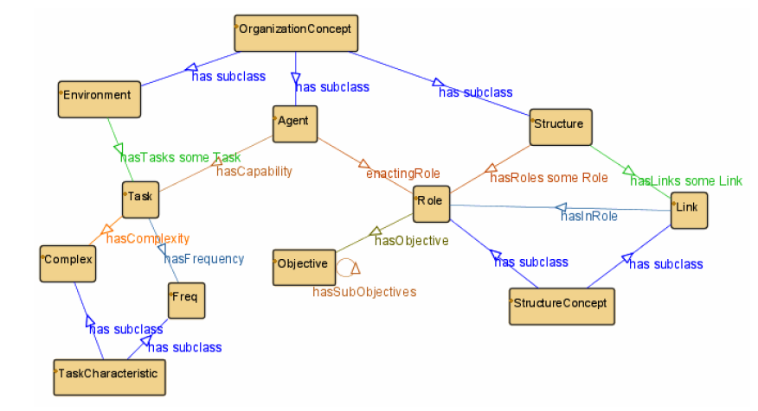

Figură 3 - An excerpt of the organization ontology

Next, we will discuss organizations as structures and we will analyze the *OperA Framework* that follows this design, as an example of organizational modeling. The concept of „organization as structure” is inspired predominantly from business or management.

***Organizational models*** should allow clear portrayal of structural and key issues and their response to a changing environment in such a way that is autonomous of agents behaviour. Simply put, an organizational model should be able to design and showcase an accurate view of the organizations components (norms, global goals, roles etc...), be able to distinguish between the system’s target and the agents objective and be able to balance collaboration autonomy. The OperA frameworks provides us with all of these aspects, making sure there is a clear distinction between entity and role.

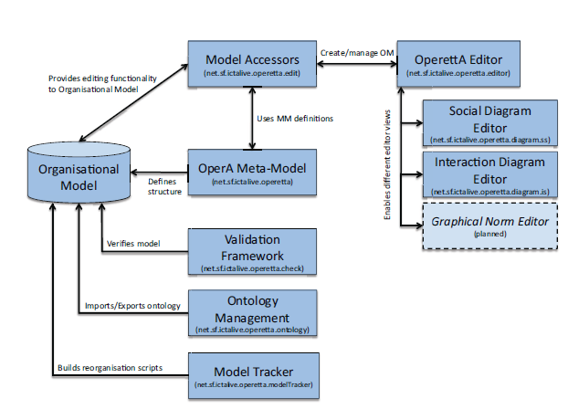

Figură 4 - OperA Tool Components [11]

The OperA framework is composed of 3 models:

* **Organizational Model** (OM): is tasked with portraying the global scopes, requirements, roles, norms, agents interactions. This model will be presented in more details below.
* **Social Model** (SM): assigns „*jobs*” to the agents, keeping in mind agent’s objective, its strengths and the global target that must be reached. (***REA*** = role enacting agent [11])
* **Interaction Model** (IM): assigns „*business*” contracts between REAs, meaning it manages their interactions.

We will focus now on the organizational model (OM) of OperA. Basically, OM tells us what we need in order to fulfill our global objectives and how to do it. Its comprised of the: ***social structures*** and ***interaction arrangements*** (here the OM describes the organizational problem in terms of roles and interactions), ***normative design*** (how the previous components should act and what rules they should obey) and ***communication architecture*** (how the previous components communicate).

***The Social Structure*** consists of a list of role specifications (including their prerequisites, purpose and rights), one of groups definitions (multiple roles of the same type, that have similar rules to adhere by) and a role dependency graph. In our conference example, we can view the authors, the PC members etc... as roles. This is an example of how OperA defines a particular role (in this case, the PC_member one) [11]:

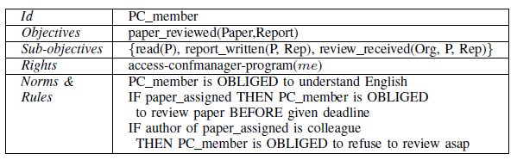

Figură 5 - PC_Member Role

An example of a group is the group formed from all the local_organizer, or the group of all program_chair. And the dependency graph is obtained from roles and their dependecy relation. In OperA, we have 3 types: *bidding* (similar to auctions in real-life scenarios and the best motion is selected)*, request* (similar to work-environements, leading to teamwork and cooperation)*, delegation* (forming a role hierarchy, with responsabilities delegates to the subordinates).

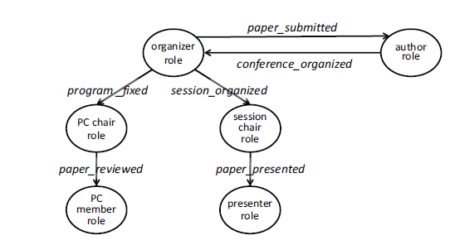

Figură 6 - Role dependencies in a conference [11]

***The Interaction Structure*** can be seen as a play, consisting of multiple scenarios, that follow a certain script, in a certain order. Example of *scripts* are paper_review, paper_presentation or registration_paper. The *scenario* involves the script and the actors, aka the roles, describing regulations or possible results. A key point to remember is that the interaction scenes don’t describe in detail the activities that take place, rather they have declarative description, that showcase the global aims of the communication. In this way, the agent has freedom to achieve its objective however it wants. In OperA, such expressions are called *landmarks* (conjunctions of logical expressions that are true in a state) and if we sort the actions to appear in the order they are executed, we obtain a *landmark pattern*.

***The Normative Structure*** indicates the *how, when* and *which* individuals should obey the norms (the rules; e.g., in our scenario, PC_member cannot review a paper that belongs to a colleague) of the organization. There are 2 types of norms: *abstract* (visions of the organization) and *concrete* ones (*constraints* – cannot be broken - and *regulations* – can be broken). In OperA, the rules are specified using logic that is conditional, relativized and temporal. E.g.: „*The authors should submit their contributions before the submission deadline*” can be written as *Oauthor(submit(paper) ≤ Submission_deadline)* [1]. It is important to remember that abstract norms need to be translated into concrete ones, in order to be better handled by the organization. E.g.: *submit(paper)* can be written as *send_mail(organizer, files) ∨ send_post(organizer, hard_copies) → submit(paper)* [11].

***The Communication Structure*** indicates *what* we are talking about and *how*. In OperA, this is viewed as the content and the languaged that is used for communicating.

# 3.Institutions:

Up until now, we have discussed organization from a structural point of view. Now we move on and study them from an institutional point of view. The term „*institution*” has its origins is economic and social perspectives.

Institution are deeply interconnected with norms. What is a *norm*? Simply put, a ***norm*** is a rule, that the system views it as truth and constraints the interactions happening inside it to follow that particular rule. As I said previously, institutions facilitate and implement the normative nature of organzations; in a way, institutions encapsulate organizations. If we think about it, roles, a structural concept, can be perceived as normative: roles produce a set of rules that need to be followed by a limited group of individuals.

According to the Oxford English Dictionary [12]:

* ***Institution***: An established law, custom, usage, practice, organization, or other element in the political or social life of a people; a regulative principle or convention subservient to the needs of an organized community or the general ends of civilization.
* ***Norm***: A standard or pattern of social behaviour that is accepted in or expected of a group.

To summarize, ***an institution*** describes the interactions and communications within an organization on a normative basis, presents exchange mechanisms, makes a connection between organizational and individuals views and standardize the rules governing external behaviours to the agents. In more depth, ***a set of rules*** is capable of defining the correct and wrong course of action and, with them, underlying the obligations that result from a valid action or the sanctions applied to an incorrect one; all of this while keeping a log in its internal state. As such, ***an institution*** can be viewed as a set of rules that judge some (not automatically all) of the actions that are performed by the agents, as right or wrong within the offered context.

The relationship between institutions, organizations and norms can be expressed in the following picture:

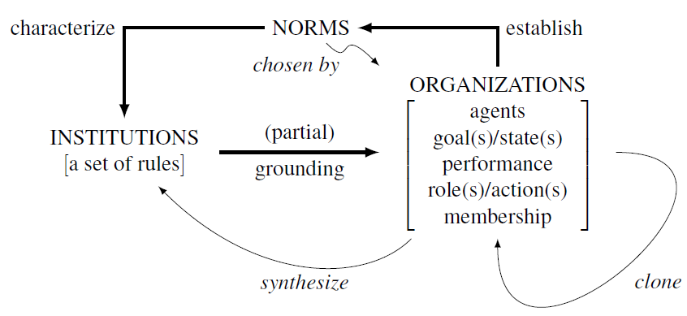

Figură 7 - Relations between insitutions, organizations and norms

We present the following explanations:

* We can think of the list of **norms** as a signature for the institution, defining the „rules of the game”, that can be interpreted in various ways by the agents;
* **An insitution** is obtained from an organization that recognizes a set of rules. **The organization** puts norms in place, in order to achieve its objective, taking also into account different aspects such as performance or agents intelligents. Through the actions of its entities, organizations gain some control over which norms to choose for different situations, thus creating disruptive OM that have the role of „game changers”. Because of this, new organizational models may be cloned and obtained, thus leading to the formation of new institutions;
* **Agents** populate the system. Because they are dynamic and influence the environment, bringing change into the equation, they may be able to redefine, replace or build new norms as a response to the constant evolving environment or as a response to the actions of different entities; thus influencing the institutions. In practice, agents can be part of multiple institutions at one given moment in time and it is highly possible that norms from one system will conflict with the rules from another. We cannot exclude this scenario (think of institutions that started as individual branches and then formed a conglomerate) and, because of it, it would be wise for agents to have the ability of knowing/finding out the potential consequences of their activities before performing them; so that we won’t have to deal with an entity that makes a correct operation in one system, only to breach the rules of another.

As we are aware from [13], an environment is a finite set **S** of *states*: **S = {s0, s1, ...}**. An agent can perform certain *actions* in this environment or, otherwise said, certain *events* can take place in it: **E = {e0, e1, ...}**. So, we can perceive an organization in 2 ways, either *state-based* or *event-based*, but neither approach is sufficient alone because we cannot establish the state of the system only from a sequence of events, nor can we find out how the system got where it is just from a sequence of states. One might prefer the *event-view* because it facilitates the focus on ordering that may be critical for the evolution of states in a system. On the other hand, the second approach, *state-based*, concentrates on the important phases from the system’s evolution.

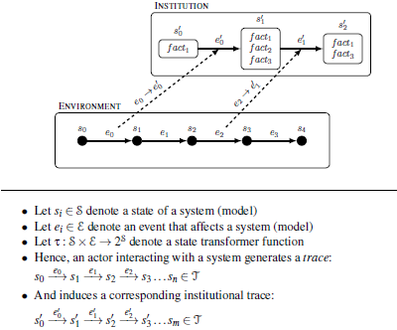Having all the data, we can outline an informal model that satisfies the requirements as such: We use a (partially) observable environment, where agents events (**ei**) produce changes in the environment (state transitions), but some of these events are mapped to institutional events (**ei’**) that lead to institutional state transitions, by adding or deleting institutional facts. A graphical representation is situated below, which highlights the interaction between an entity and an institution:

Figură 8 - An Informal Model

If the event does not influence the institution, then the system state does not shift (e.g.: the author can receive a review only if he/she submitted a paper). We use the notion of ***conventional generation*** to define an action from the real world that was mapped as an institutional one.

Why is all of this important? In this way we can build computational models for dynamic systems and they can answer questions such as „*how did we get here?*” or „*where can we go?*”. Knowing all these informations, one can easily deduce how a multiagent system may be able to use the relation between the formalization of events and states. What is left to do is the need to:

* define how to **express constraints on institutional behaviour** and...
* how to **map external actions to internal-institutional ones**.

One convenient way of **expressing constraints on institutional behaviour** (we will focus now on the dashed lines from the *Figure 8*) is through the combination of:

* *Obligations*: are the aftermath of some events, but when we refer to them, we need to realise and accept that they are part of the **institutional structure**. The idea is simple: first, we observe and admit that a particular action of an agent is relevant to the institution (**ei → ei’**); second, we take notice if the event is allowed and only after that, we might add the obligation. A follow-up action may produce a state of circumstances that meets the obligation, allowing it to be eliminated from the institutional state. In our scenario, a reviewer has the obligation to write a review when he or she is assigned a paper and that obligation is dropped in the moment the review is published. Simply put, an agent must take an action that results in a particular institutional state that satises the obligation.
* *Permissions*: indicates whether some actions are allowed for a particular role in the current state of the institution, otherwise a violation is arised. E.g.: the authors cannot send their papers before the start of the selection period or the program chair cannot close submissions before the due date.
* *Powers*: They are also part of the institutional structure, determining whether an institutional event has any effect on the institutional state. Just like with obligations, first, we observe and admit that a particular action of an agent is relevant to the institution; second, we take notice if the event is allowed and enpowered for that **principle** from our state of interest. Just like in real-life scenarios, power can be taken away if abused or if it is of no longer use. E.g.: the program chair has the power to extend the deadline, but an author is not.

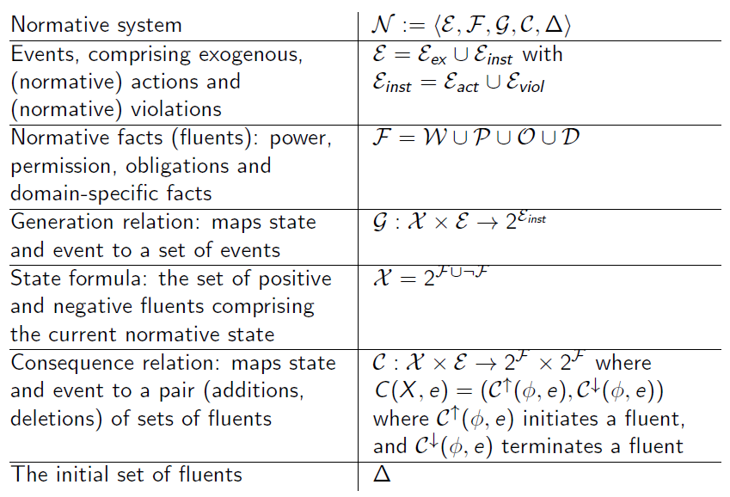For the issue of **event mapping and state dynamics**, we will define a formal model that is behind InstAL language (Institutional Modeling). InstAL’s computational model is founded on Answer Set Programming [1].

Figură 9 - Formal Model

The data interests us is represented by both the external events (**Eex = {e0, e1, ...}**) and the institutional ones (**Einst = {e0’, e1’, ...}**), as well as ***fluents*** (*obligation, permission, power* – if present in the system indicated **True**, otherwise, **False**) **F**. Some external events are related to institutional ones and are mapped accordingly: **ei ei’**, denoted by the ***generation*** ***relation*** **G**. **G** also makes sure that all institutional events possible are generated from all previous ones. When an institutional event takes place, we either add facts/fluents or delete them from **F**. This is the responsability of the ***consequence relation*** **C**, arising from all the events that **G** indentifies. And so, the institutional state ***transformer function $τ:S×E→2^{S}$*** may be realized by $C∘TC(G)$, where **TC** is the ***transitive closure***.

The InstAL language is very similar to the object-oriented ones, such as C++ or Java, so, in order to start, let’s first draw the main components used:

* *Entities*: person, paper...;
* *Roles*: author, reviewer, comitee_member...;
* *Properties*: is_in_english, is_chair...;
* *External Events*: submit_paper, open_submission, close_submission...;
* *Institutional Events*: corresponding to above;
* *2 Scenarios*: opening of submissions and review assignment.

From this scheme, we can identify two issues that arise: the order of the events matter and certain actions can be performed only by certain roles. Because we are in an institution, we can use the key concepts described above: obligation, permission and power, in order to ensure the correct execution of events.

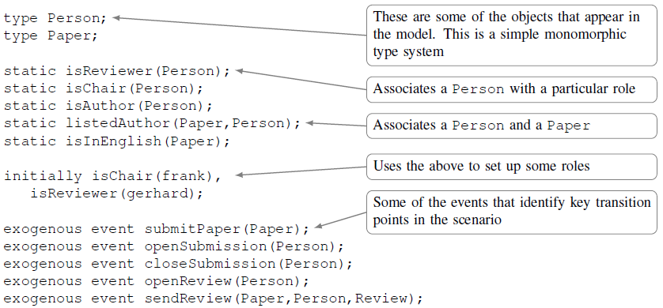

Figură 10 - Entities, Roles and Events

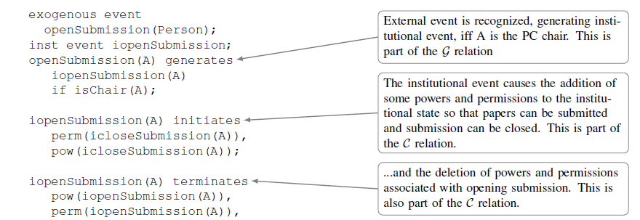Some actors are identified: Frank is a PC_chair and Gerhard is a Reviewer. It is important to note that, although power exists only inside the institution, it can be given or taken away so that it makes sure that actions follow a specific order (actions respect their intended consequences). E.g.: Frank has permission to close submissions, but it has that power only if enough time has passed since the starting period.

Figură 11 - Submissions Open

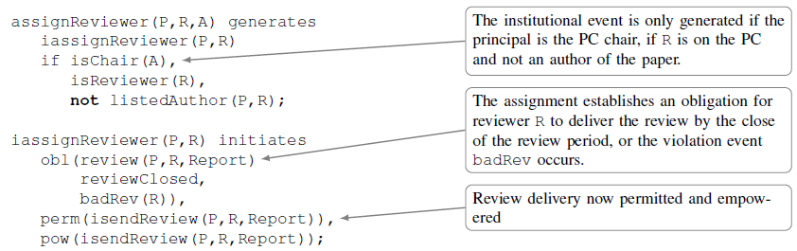Submissions are open and so, Frank has the permission and the power to close submissions. And, at the same time, the permission and power are deleted, because the action cannot be performed twice.

Figură 12 - Reviewer Assignment

A reviewer can be assigned to a paper as long as the roles are fulfilled correctly and the reviewer is not the author of the paper. To signal that the evolution of a model is controlled by external events, no dates are hard-coded in the model. Instead, we use external actions to act as deadlines i.e. the obligation must be satisfied before deadline. So, the coresponding institutional event adds the obligation on the reviewer to write a review before the review period is closed (otherwise a *badRev* violation is triggered) and also instates the permission and power for a reviewer to send a review.

Specific violations can be specified not only in case of an event that has taken place without permission but also because an obligation was not fulfilled. The fluents characterize the non-institutional state of the system, keeping track of what actions had occured.

In InstAl, we can use institutional specification to either assert if we can research *static* properties of a list of rules (obtaining all the possible traces that could occur) or to view the *emergent* properties of those norms.

Although a single institution can capture a full set of normative behaviours, we cannot expect that a monolithic structure can be desirable. A single institution with a limited range of interactions can be reused more easily, but is not realistic in the context of real-life. After all, institutions are situated in a social construct with norms they must interpolate, so institutional workflows are unavoidable. If we synthesize a single internally consistent institution from multiple institutional specifications, this process is called *institutional composition*. A multi-institution is comprised of multiple, connected institutions, each with their own set of rules and, most likely, conflicting norms.

# 4.Agents in Organizations:

As mentioned previously in the paper, agents have autonomy, being motivated by their own objectives and beliefs. An important challenge that represents a complex problem and an open topic of research is how to design an entity such as it can evaluate if it has the right properties and characteristics and if its goals align with the ones of the organization that it wants to join. Simply put, an agent must inquire if adhering to an organization is a good choice. To solve this issue, agents are designed from the start with the goal of joining a specific organization and their goals are in line with the goals of the system. But as we already discussed, organizations have also their own purpose and exist independently of the agents populating them, thus we cannot assume that all entities are known at design time, so we need agents with organization-awareness, so that they can make an educated decision whether or not to negotiate their attendance in a system.

We analyzed, so far, that an organization, by describing the way interactions can arise in an environment, is capable of delegating roles (positions to be occupied by „players”), which contribute to the overall performance in accomplishing the global target. The difference between role and agent is obvious:

* ***A role*** is an abstract representation of a service inside a system and comes with a predefined set of rules and requirements and a desired behaviour, from the organization’s perspective. The system is not really concerned with who occupies the role as long as they have sufficient capabilities.
* ***An angent***, on the other hand, is capable of flexible actions in order to meet its goals and can embody a role if that role is suited for it. Entities act, roles do not. Of course, between agent A and agent B, we might see a different global output, depending on which one of them assumed the role, because they each have a different individual objective and will determine which protocol is more appropiate to use in regards of their role in the system.

The capacity to dynamically assign jobs to diverse agents allows the organization to adapt to changing goals and environments.

Existing strategies for assigning roles to agents perform this kind of process with the idea of role enactment through communication with the organization in mind and by adopting the role’s objective as the agent’s purpose. To do so, it is checked whether or not entities goals and roles’ ones are compatible. But this approach assumes that the organizational properties are existent and available to the agents and that the entity has the capacity of judging whether or not can play a role in the system (exactly the initial issue that we encountered), so this is not really a feasible solution.

Role-enacting agents must be capable:

* To perform duties assigned to them by the role or enforced by role interactions within the system, including the capacity to access the role's resources;
* To communicate with other agents that have the same role;
* To reason about which of their resources can be utilised in order to reach the role’s target.

So now, a few questions arise: *How to integrate agent goals and role goals? How to integrate agent norms and role norms? If they conflict, which one to choose?* At an intuitive level, a role-enacting agent will achieve the role goals, will behave according to the role norms and will interact using the role’s interaction rules.

A proposed way is to equip the entity with a ***governor*** (an interface to the organization). This interface will ensure that the agents will follow the rules outlined above. But, this approach is not flexible enough and it does not allow the agent to resolv a problem in its own style, rendering the entities practically invisible to the organization, because the governor enforces how and what the agent can do.

From the *agent’s view*, if an organization provides a detailed role description, then, the entity is not required to perform a huge degree of interpretation and its behaviour will automatically comply with the role’s behaviour that they will enact. Again, this solution is not a good one because we’ve said it before: in real-life situations, we encounter open systems where agents are assumed to run independently from the organization.

From the *organization’s view*, the system is concerned with the impact that the attitudes of agents will have on the performance of roles. In agents literature, we can distinguish different types of entities, such as selfish, honest, dishonest or altruistic. So, we encounter another questions: *How to order role and agent goals/norms? What about sub-goals*?

By participating in an organization, it is implied that some sort of mutual benefit exists to be gained by both parties involved: agents and system. Depending on the type of agent, we can distinguish between 3 main role-enactment styles, assuming that the agent is capable of reasoning about the role enactment:

* *Selfish Style*: agents give priority to as many as possible of their own goals and rules over the interest of the organization;
* *Social Style*: the agent will give priority to the objectives and rules of the role and try to include as many of their own targets and norms as possible;
* *Maximal Social Style*: the entity prioritizes the assignments and rules of the role.

We can think of the relationship between agents and organizations in terms of ***contracts***, providing a new interesting strategy. A contract is a statement of intent that regulates behavior among organizations and individuals, specifying time periods, terms and conditions, prerequisites or possible sanctions in case of violations. The contract will outline the *roles* (social component of the contract) and the *performance* (the interaction component).

# 5.Evolution of Organizations:

Overall, the objective of an organization is to obtain and provide stability. But, as we already know, organizations, agents and the environments in which they reside are never static, being in a continuous transformation. Agents influence the environment and the system, the environment and the organization respond and so on, creating a cycle. The process of reorganization appears in face of environment mutability (***external stimulus***) and/or in the face of modified intentions, strategies, targets or interactions (***internal stimulus***).

With this in mind, we conclude that a multiagent organization must be able to implement dynamic changes in its own structure, not only in the agents’ architecture. Depending on the type of system and on the scale of the impact that the changes produced in the environment, adaptation can be endorsed by modifying the agent’s behaviour, by changes in interactions or by revision of the social structure.

Organizational evolution is defined by a tradeoff between ***regulations*** (the norms that express the global objectives) and ***autonomy*** (trying out alternative behaviours that may not be rule-compliant or may provide a degree of agility).

As observed in human interactions, with time, changes become the norm and are integrated in the system, forming a cycle. The cycle moves from explicit rules, where compliance is shaded by autonomy, to implicit rules, where autonomy establishes what is newly compliant, leading to explicit statement of the implicit rules and so on.

In organization theory, an interesting problem arises from trying to determine the performance of an organization. The performance can be determined by the sum of all the achieved goals at a moment in time. Considering that the system is evolving, as we stated previously, there is concerned with the evaluation of performance and also we have the following question: „*when should we reorganize in order to have the greatest performance?*”. We know that if we reorganize the system, its stability will be momentarly compromised. So, the logical conclusion is to adapt the multiagent organization when it leads to an increase of utility, i.e. reorganize only if performance is improved after the fact and if the cost of the reorganization is acceptable or it will be insignificant in comparison with the advantages obtained.

In order to reach a decision, Durfee selects three factors that should be considered before a reorganization: *structure, behaviour and task-environmental factors*. The research also shows that is a multiagent organization is capable to adapt to different scenarios, its performance will improve. The concept of *dynamic adaptation* is also important because it refers to changes that are brought up by adding or removing different components of the system, but the organization must be able to evaluate its own health and take actions to ensure it before it makes any changes.

Emergent organizations are those in which an external entity or a small group of decision makers within a larger community determines the nature, structure, and objectives of the system. They have a bottom-up creation, rather than top-down definition and result in the Institutional Analysis and Development (IAD) framework. IAD can address many real-world (human) scenarios in which we face many and complex interacting variables and contexts within contexts (multi-institutions).

Emergent organizations have a few interesting applications:

* Approach encourages unconventional solutions for „messy" common-pool resource problems;
* Solutions are derived from actor preferences resulting in high stability and resilience;
* Approach takes account of a range of factors and discourages simplistic re-use.

# 6.Conclusions:

Throughout this paper we discussed an organization-oriented view on multiagent systems (MAS) and its components required to make it possible, refering to the concepts outlined in Chapter 2 of [1]. The topological structures of human organizations (borrowed from sociology) have many similarities with the coordination techniques and structures adopted in agent systems and this particulat relationship is used for designing and analysis of multiagent organizations. Therefore, if we set on a specific structure, it is possible to construct, fairly easily, a multiagent system that follows certain rules and restraints.

We also discussed important research issues such as organization-awareness agents, that represent a hot topic in the field and still an unsolved problem. The goal is to try to develop and formalize languages for programming them.

Another interesting controversy is the interaction between humans and artificial agents in organizations. This is yet a not so well understood topic, that, in the future, might be able to simplify and aid the human life. Should we consider an autonomy approach or a teamwork view of this problem?

Finally, we talked about organizational adaptation and evolution. Reorganization is needed in order to enable systems to enforce or adapt to changes in the environment. The lack, in most cases, of a formal basis makes it difficult to develop theories about reorganization, prevents the comparison of approaches and results, and makes it difficult to adapt models to other domains or situations.

To conclude, multiagent organization is a challenging topic, that is still developing, with lots of questions still unanswered, but with a practical view on different scenarios from human world. As the research continues, I am sure that we will discover more possible fields in which we can incorporate them.

# 7.References

|  |  |
| --- | --- |
| [1] | G. Weiss (ed.), Multiagent Systems, Second Edition, London, England; Cambridge, Massachusetts: The MIT Press, 2013. |
| [2] | M. Wooldridge, An Introduction to MultiAgent Systems, West Sussex, England: John Wiley & Sons Ltd, 2002. |
| [3] | J. Ferber, O. Gutknecht și F. Michel, From agents to organizations: An organizational view of multi-agent systems, Springer-Verlag, 2003. |
| [4] | K. Sycara, „Multiagent systems,” *AI Magazine,* vol. 19, nr. 2, pp. 79-92, 1998. |
| [5] | A. Rice (editor), The Enterprise and Its Environment: A System Theory of Management Organization, Routledge, 2001. |
| [6] | J. Vázquez-Salceda, V. Dignum și F. Dignum, „Organizing multiagent systems,” *JAAMAS,* vol. 11, nr. 3, pp. 307-360, 2005. |
| [7] | G. Weiss, M. Nickles, M. Rovatsos (editors), Agents and Computational Autonomy, pp. 227-236, Springer, 2004. |
| [8] | M. Wooldridge, „YouTube - An Introduction to MultiAgent Systems,” 28 January 2010. [Interactiv]. Available: https://www.youtube.com/watch?v=mGmhOHUoNMY&list=PLDE4D1288C05C63A9. [Accesat 23 January 2022]. |
| [9] | H. Mintzberg, Structures in Fives: Designing Effective Organizations, Prentice Hall, 1993. |
| [10] | E. Argente, J. Vicente și B. Vicente, „Multi-Agent System Development Based on Organizations,” *Electronic Notes in Theoretical Computer Science,* vol. 150, pp. 55-71, 2006. |
| [11] | V. Dignum și H. Aldewereld, „OperettA: Organization-Oriented Development”. |
| [12] | Oxford, „Oxford Learner's Dictionaries,” [Interactiv]. Available: https://www.oxfordlearnersdictionaries.com/. [Accesat January 2022]. |
| [13] | L. Leuștean, „Logic for Multiagent Systems,” Bucharest, 2021-2022. |